DBMS LAB-7
QUERY 1:
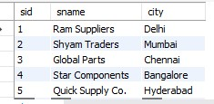
QUERY 2:
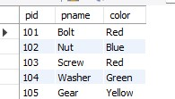
QUERY 3:
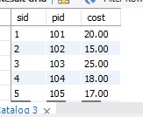
QUERY 4:
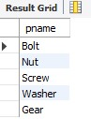
QUERY 5:
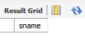
QUERY 6:
QUERY 7:
QUERY 8:
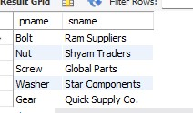
QUERY 9:
